# Installation of Tura 4.0.0

1. Download Eclipse Mars for Java developers.
2. Extract Eclipse from archive and launch it.
3. Navigate to Eclipse Marketplace

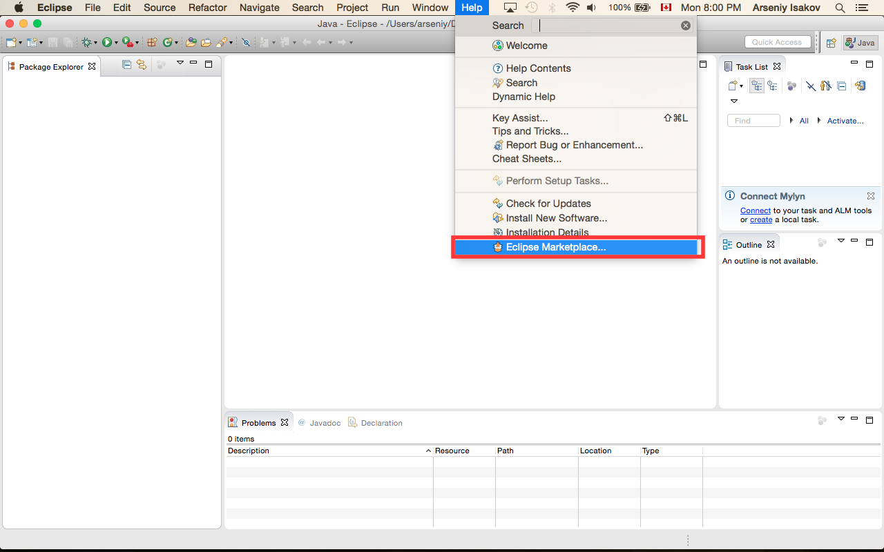

and find modeling framework Epsilon 1.2

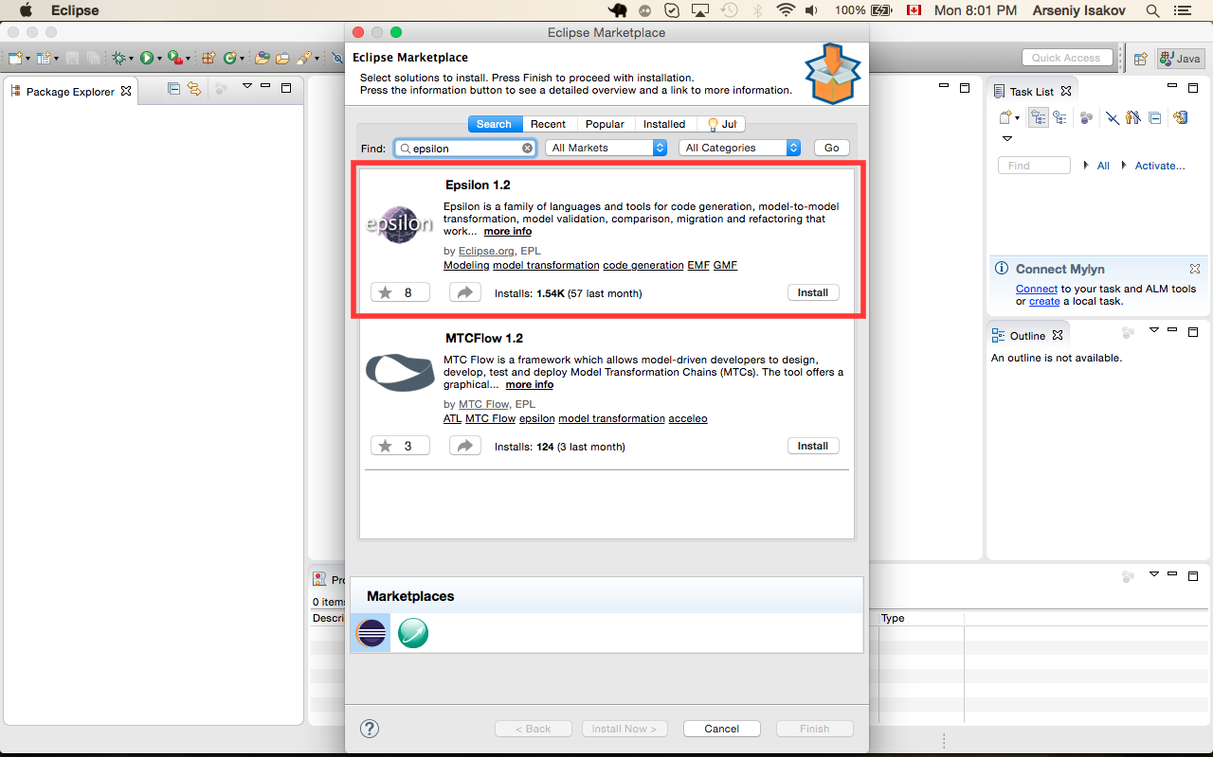

1. Install Epsilon 1.2
2. Download Tura eclipse plugin from <http://sourceforge.net/projects/tura/files/>
3. Select “Install New Software” in Eclipse

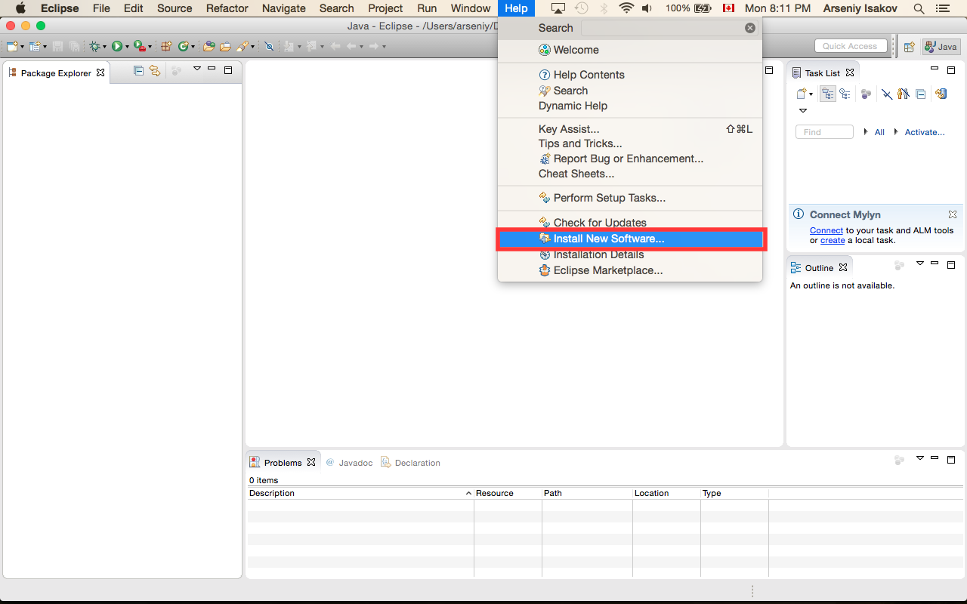

1. (1) – press “Add” button and select location of downloaded previously Tura archive

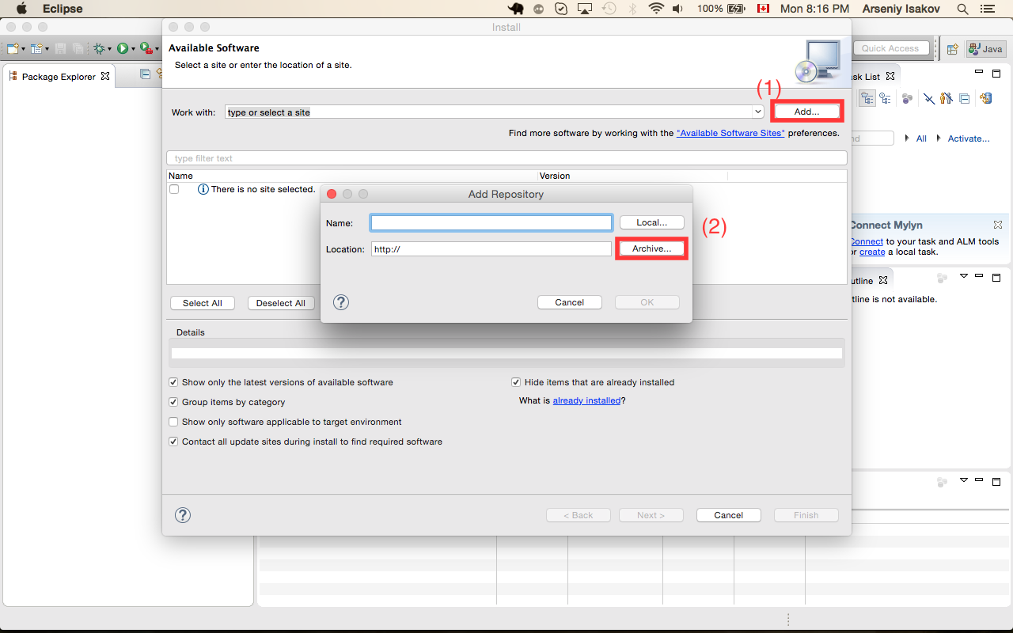

1. Select Tura application, press “Next” button and follow wizard flow

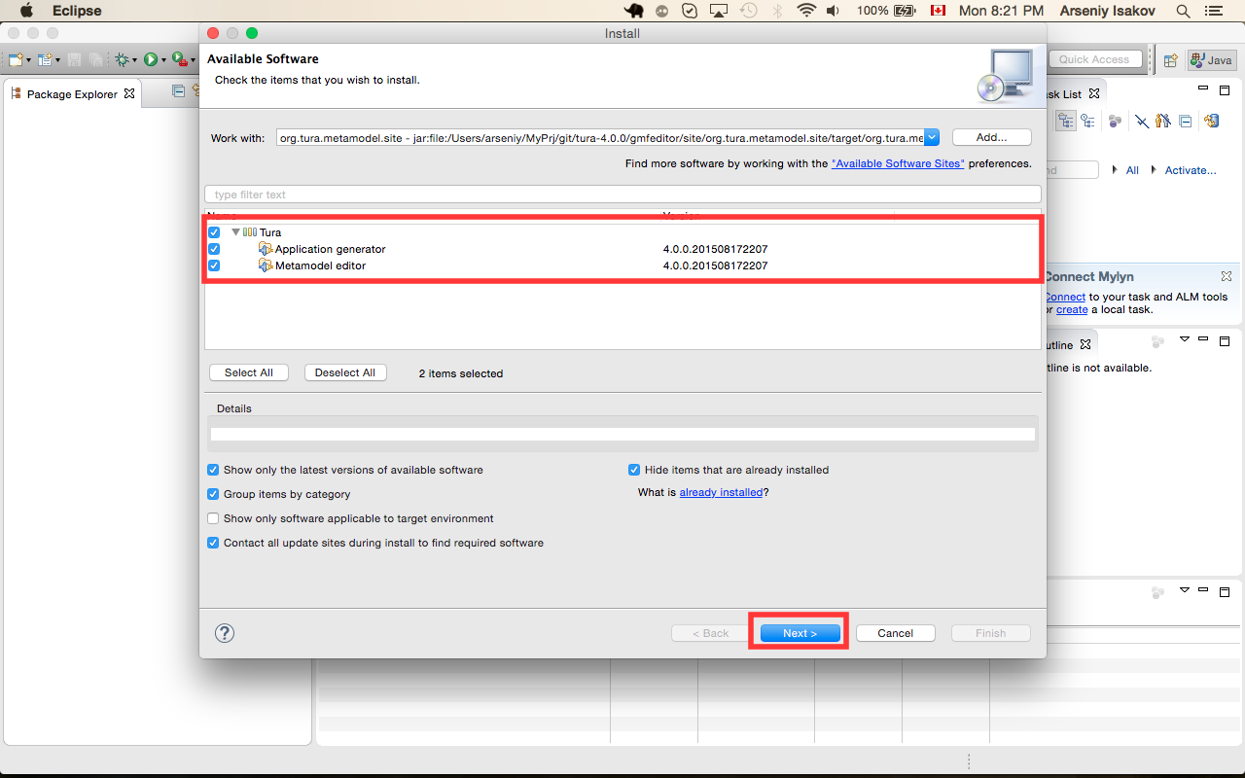

# DataBase configuration

1. Open <http://www.postgresql.org/download/> and select you platform and download postgresql database.
2. Install postgresql.
3. Download postgresql admin tool from <http://www.pgadmin.org/download/> and install it.
4. Run pgAdmin.
5. Configure connection to database

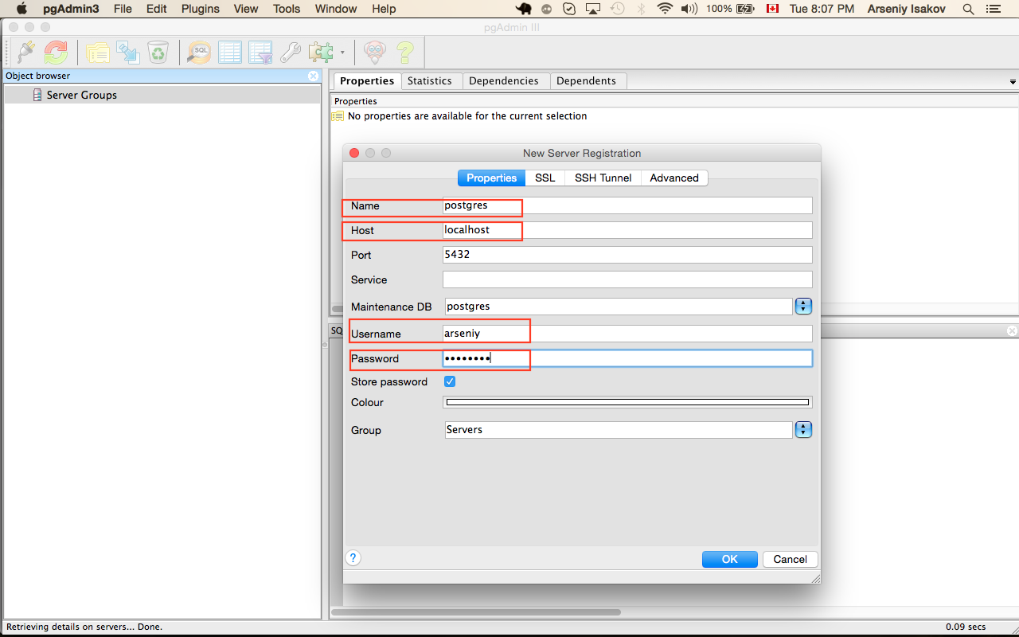

1. Create hr schema

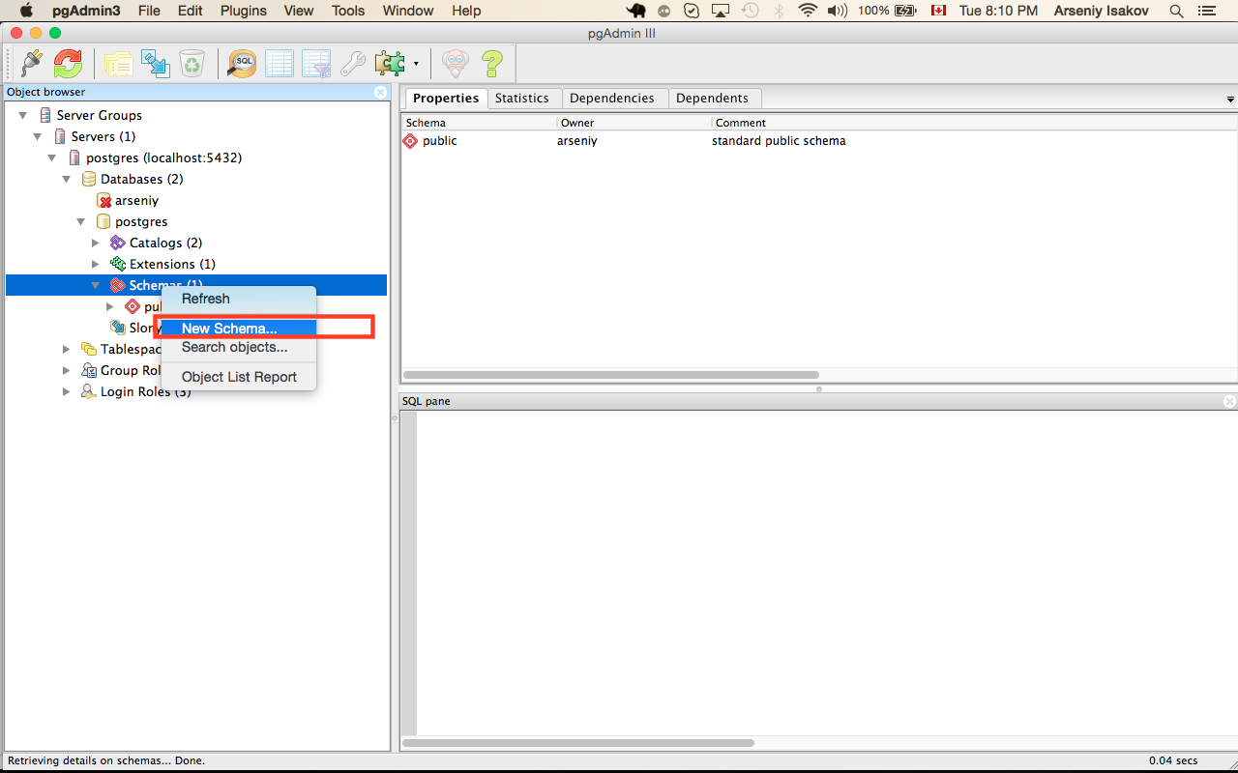

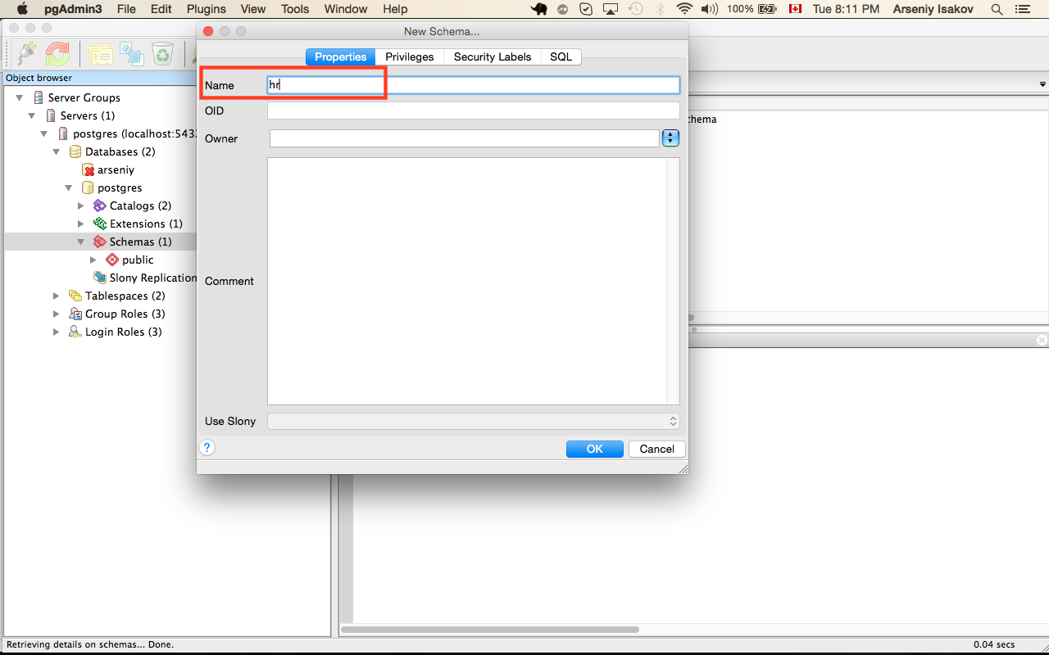

1. Grant access to new schema. To do that run sql tool

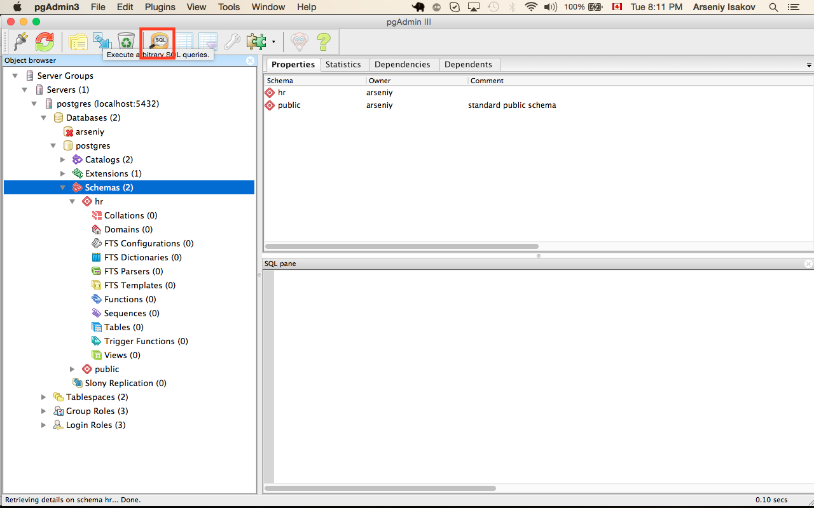

And execute query:

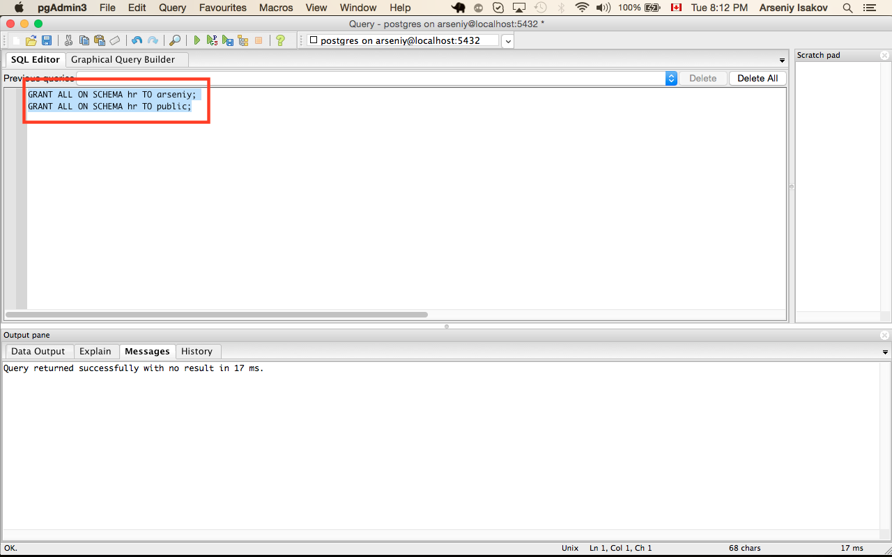

# Installation of application server

1. Download glassfish4 (full platform) from <https://glassfish.java.net/download.html>.

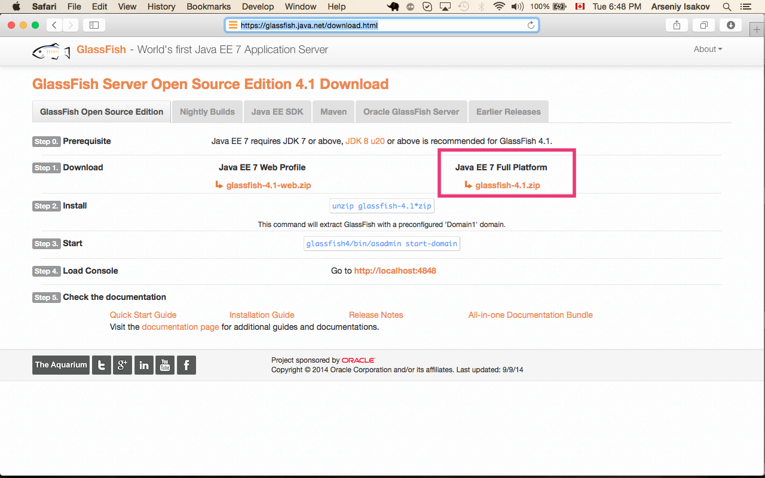

1. Download Hibernate from <http://hibernate.org/orm/downloads/>

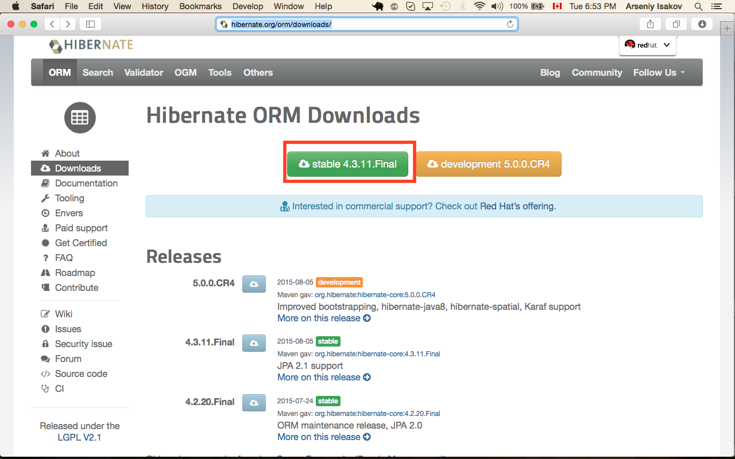

1. Download postgres SQL deriver from <https://jdbc.postgresql.org/download.html>

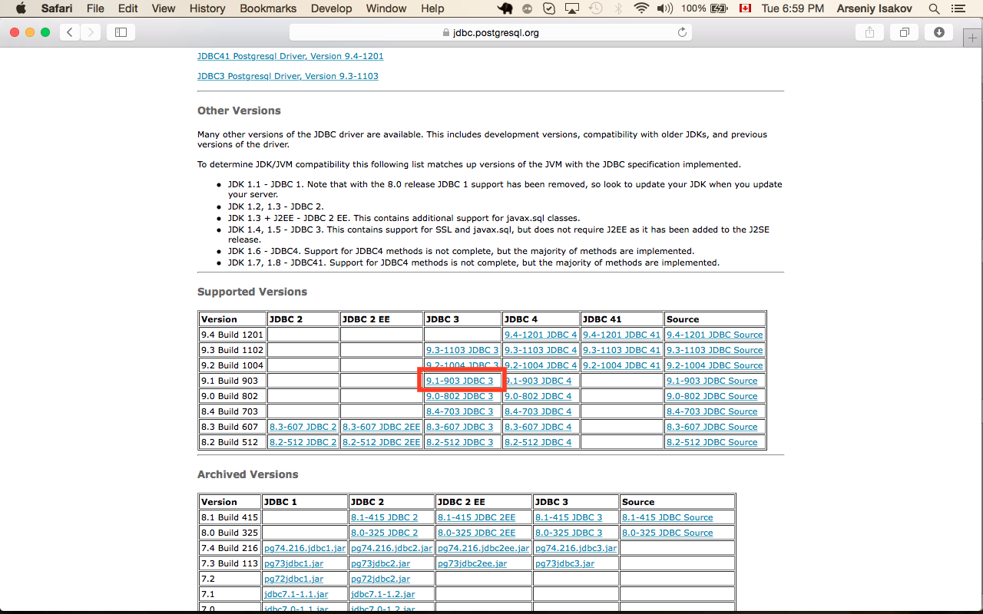

1. Extract achieve glassfish-4.1.zip
2. Copy postgres jdbc driver to <GLASSFISH_HOME>/glassfish/lib
3. Extract archive hibernate-release-4.3.11.Final.zip
4. Copy hibernate to <GLASSFISH_HOME>/glassfish/lib

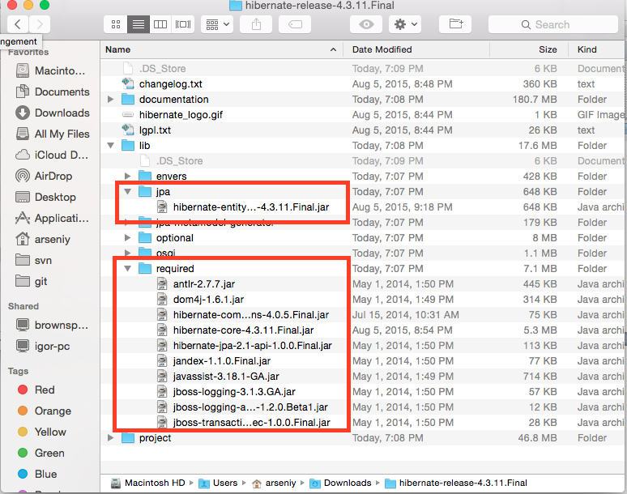

1. From command line execute following command to start server ~/glassfish4/bin/asadmin start-domain --verbose domain1

# Connection pool configuration

1. Run application server admin console in your browser (<http://localhost:4848/common/index.jsf>)
2. Select “JDBC Connection Pool” and press “New” button

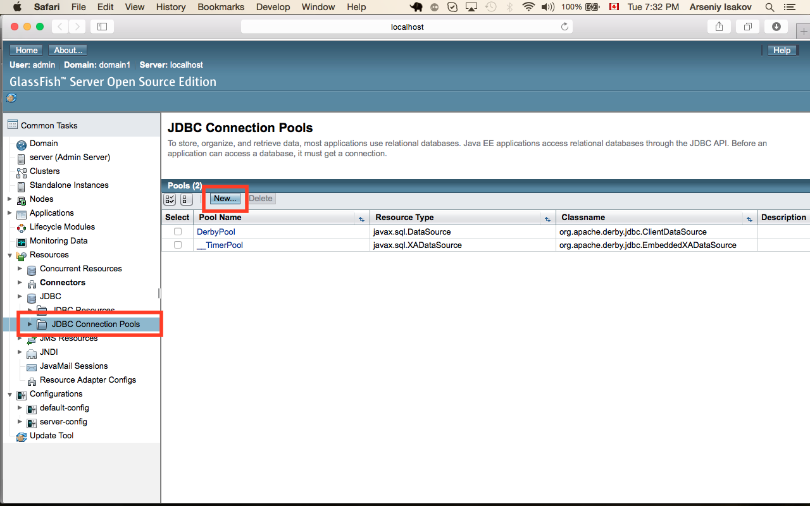

1. Populate configuration parameters and press next button

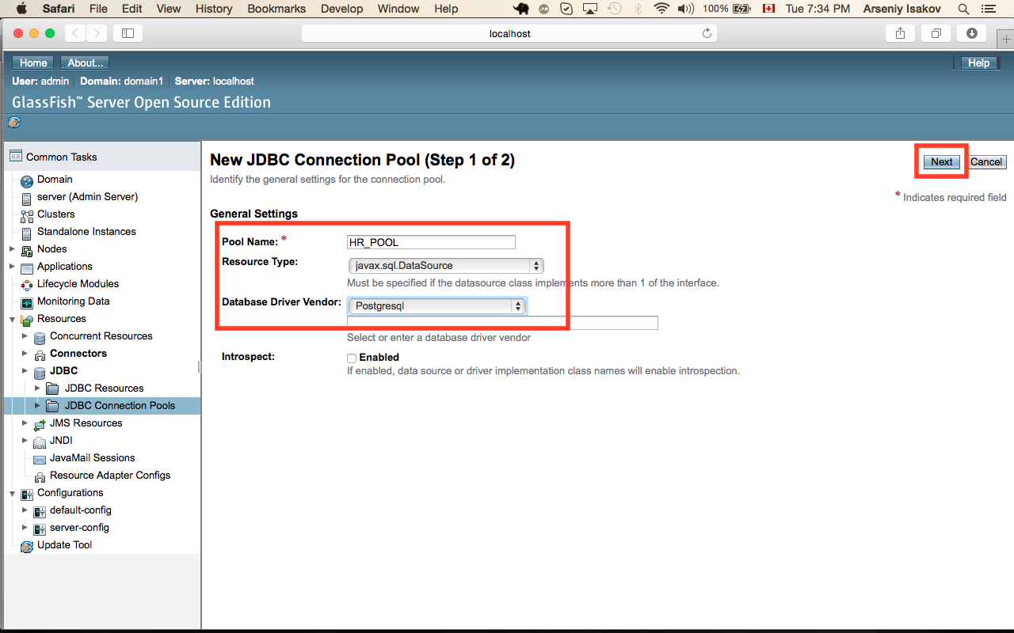

1. Enable ping to database

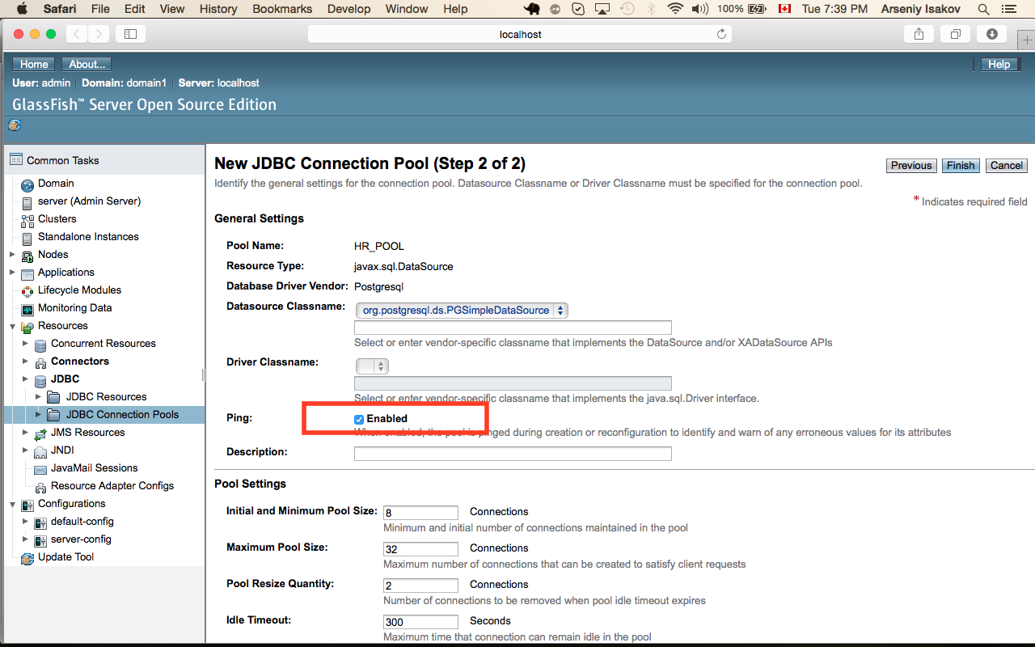

1. Populate following parameters and press “Finish” button

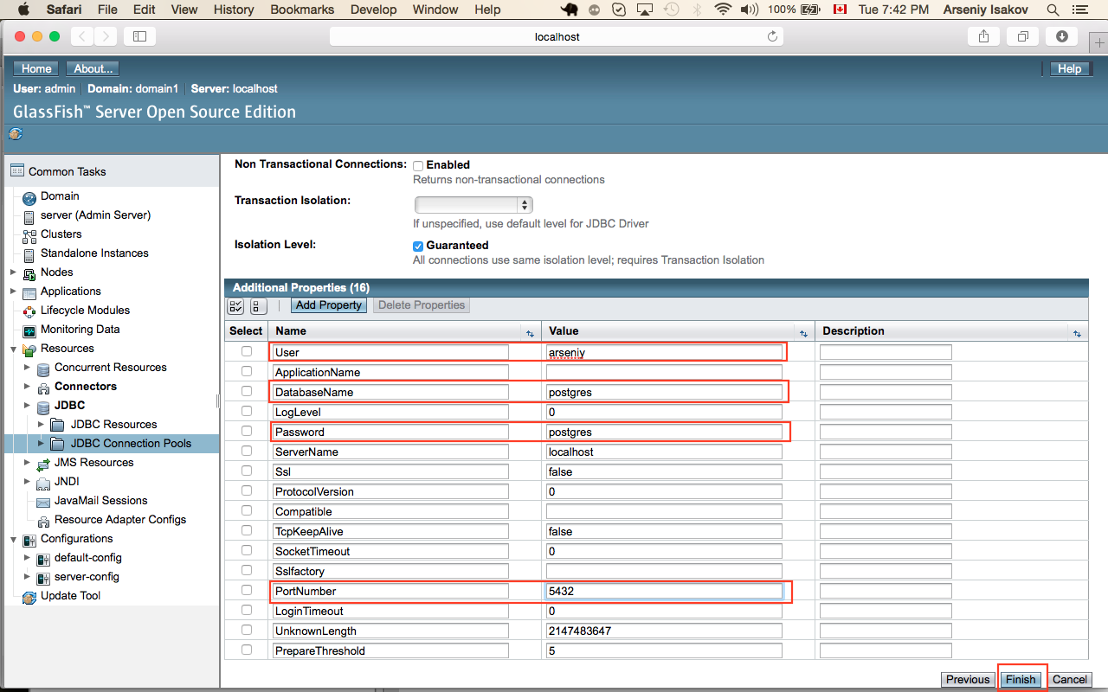

If you configured connection properly you will get following picture

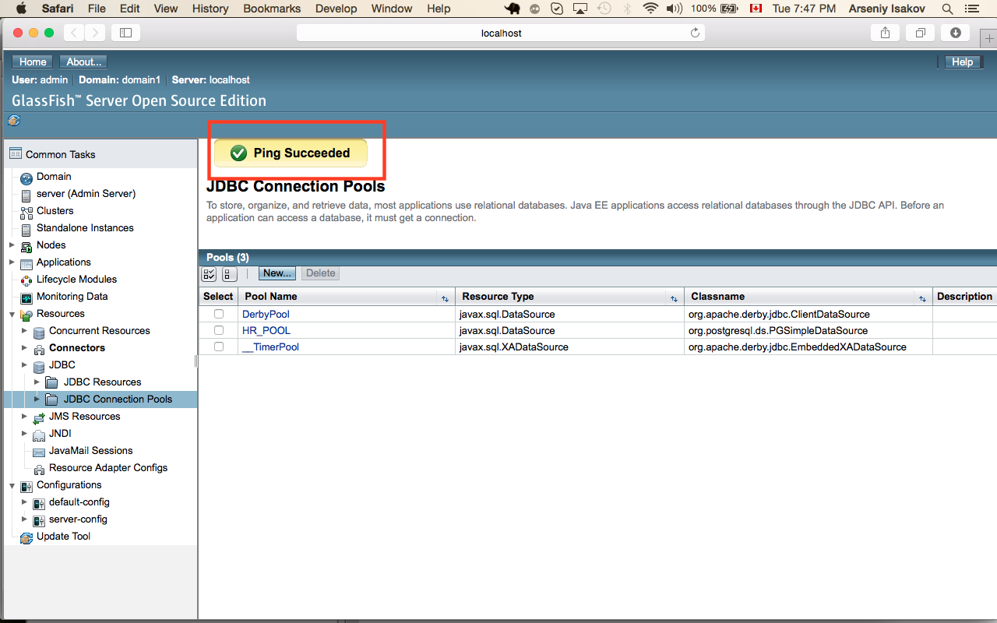

1. Select “JDBC Resources” and press “New” button

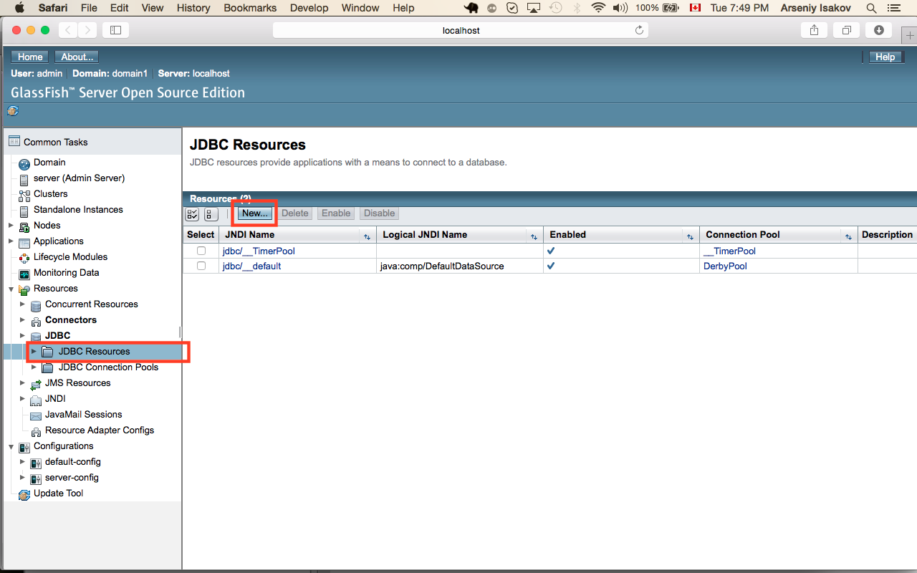

1. Enter values for “JNDI Name”, “Pool Name” and press “ok” button

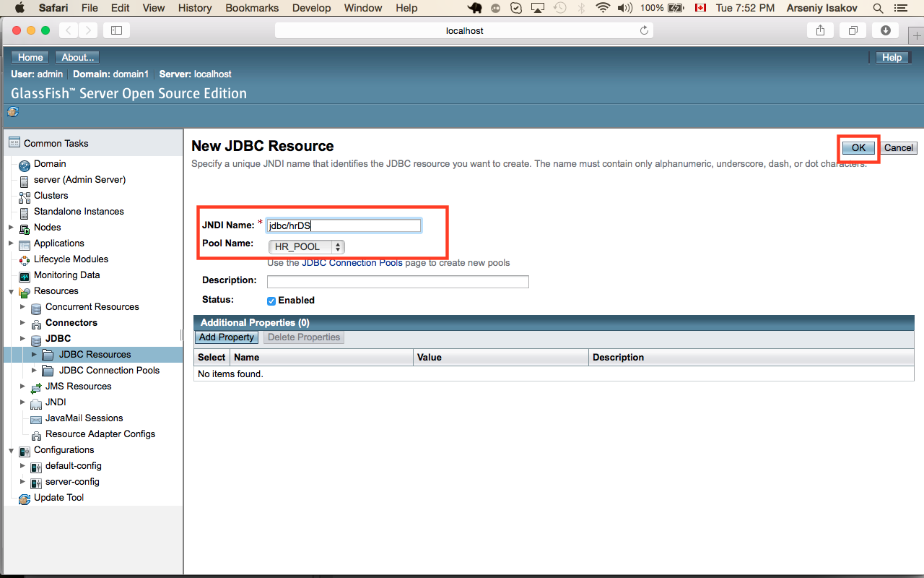

# Installation of maven artifacts

|  |
| --- |
| Modify settings of maven  Add to you profile  export MAVEN_OPTS="-Xmx256m -XX:MaxPermSize=128m" |

1. Download Tura framework from <http://sourceforge.net/projects/tura/files/>
2. Extract archive
3. From terminal execute command:

|  |
| --- |
| >cd <tura_extract_dir>/platform  >mvn clean install  >cd <tura_extract_dir>/examples/hrresources  >mvn clean install  >cd <tura_extract_dir>/examples/hrform-triggers  >mvn clean install |

# Installation of database schema

1. Run pgAdmin
2. Start sql tool

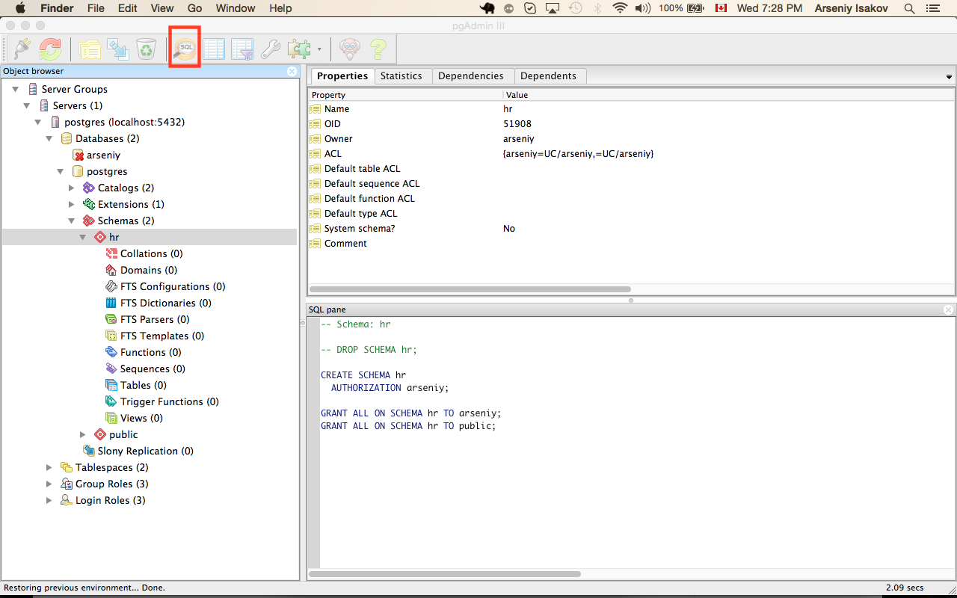

1. Import schema file <tura_extract_dir>/examples/test-form/init-data/hrschema.sql

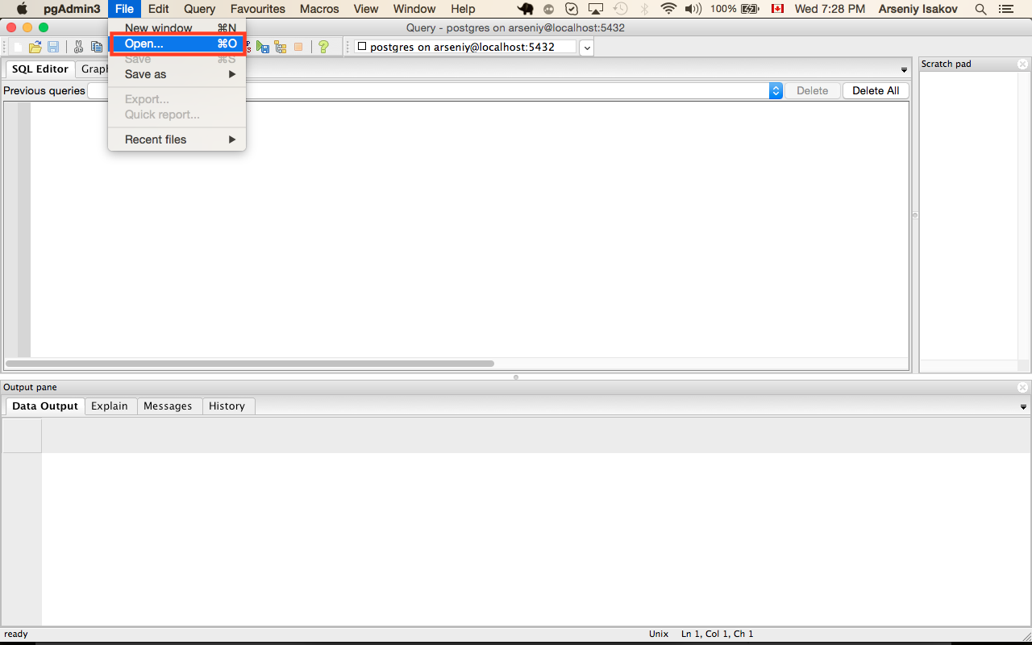

1. Run script

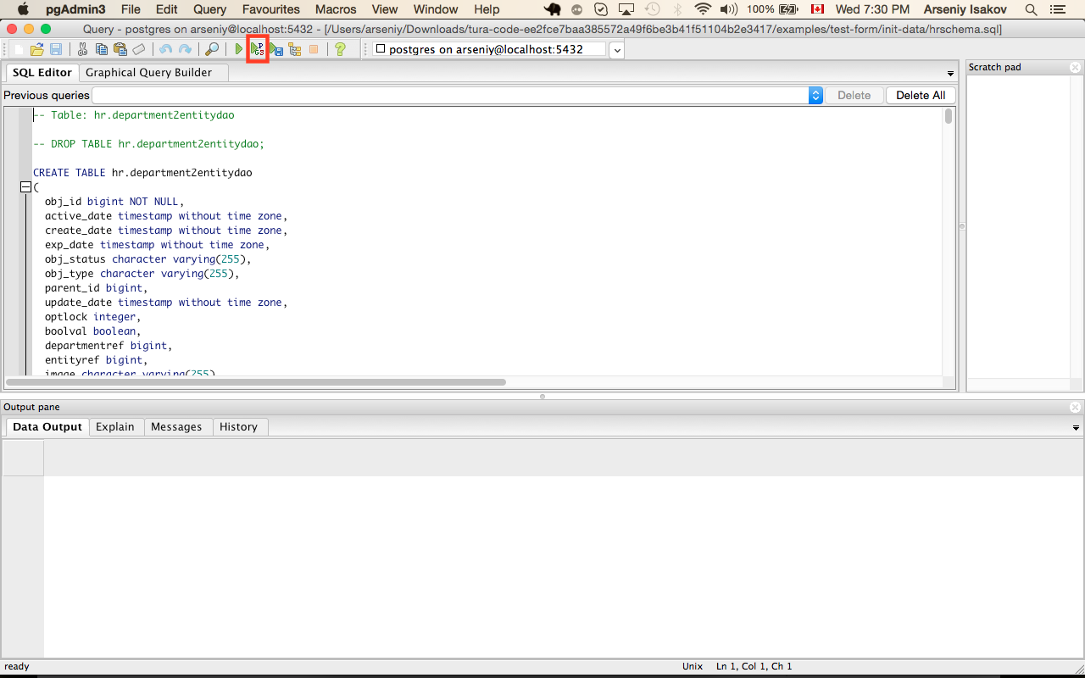

1. Import schema file <tura_extract_dir>/examples/test-form/init-data/ hrcontroller.sql
2. Run script

# Application generation

1. Launch Eclipse with Tura plugin
2. Import example Tura project inside eclipse. Example project located in

<tura_extract_dir>/examples/org.tura.metamodel.example.hrform

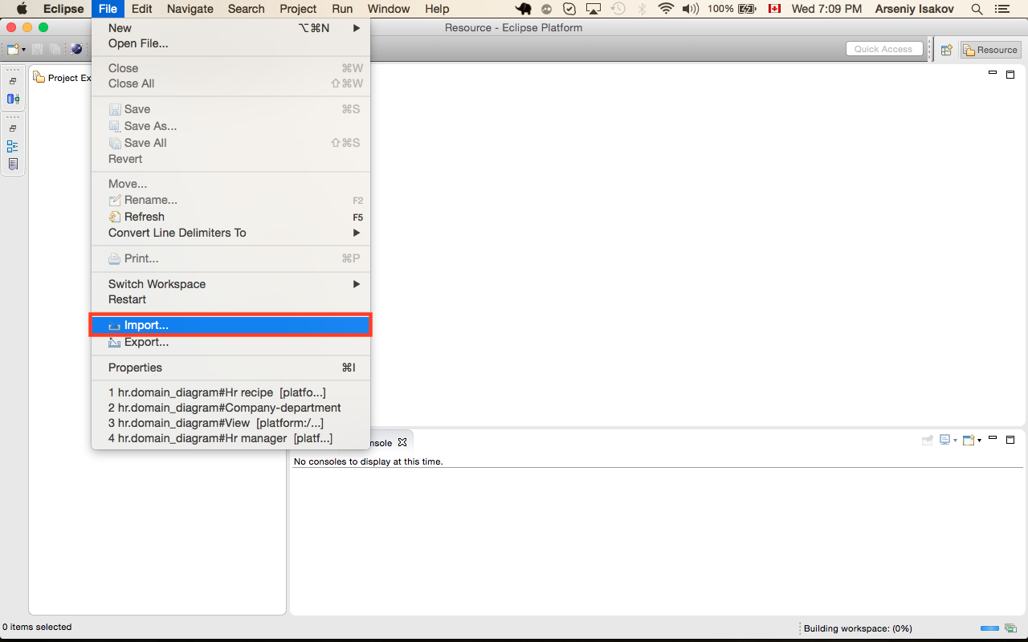

Select “Existing Project into Workspace” and press “Next”

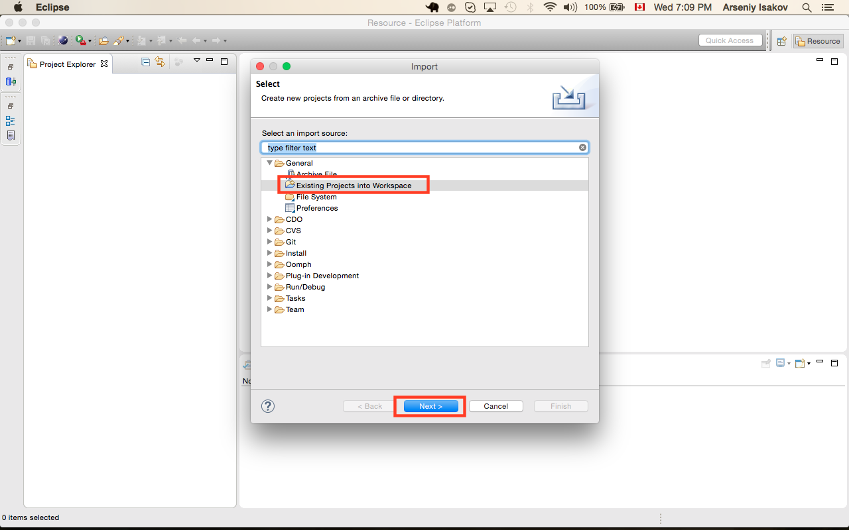

Press button “Browse”

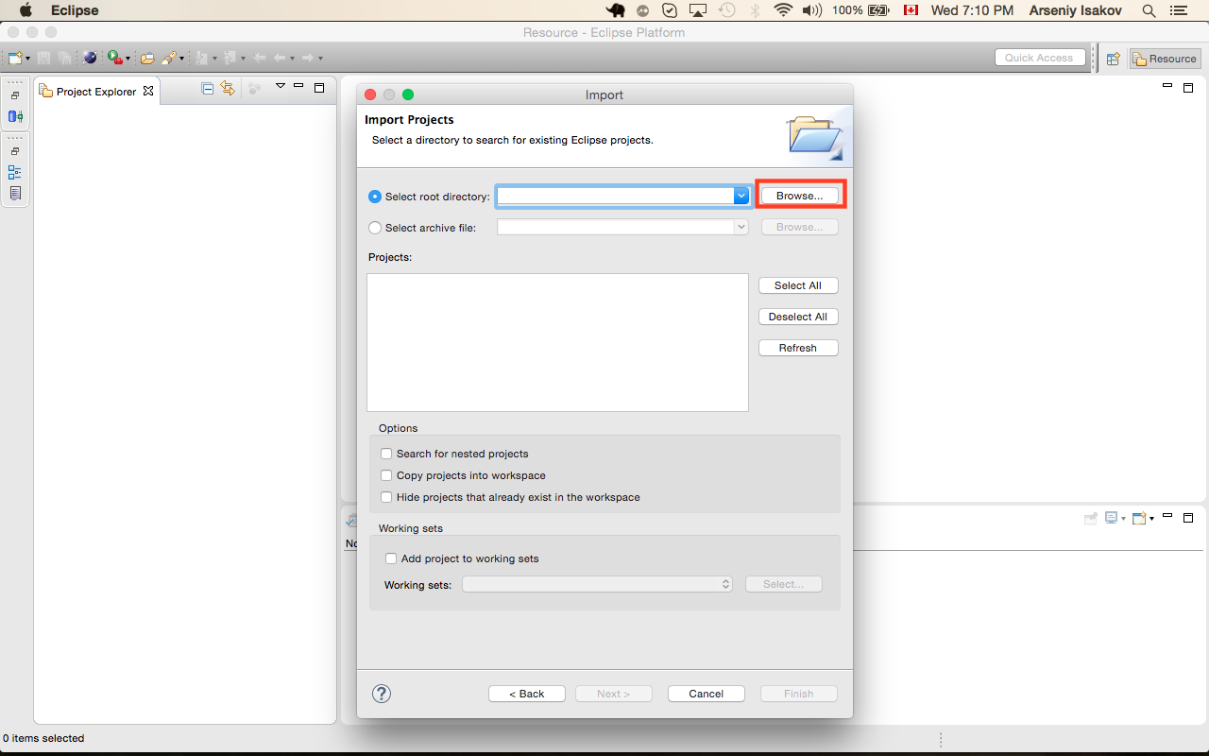

Select example Tura project

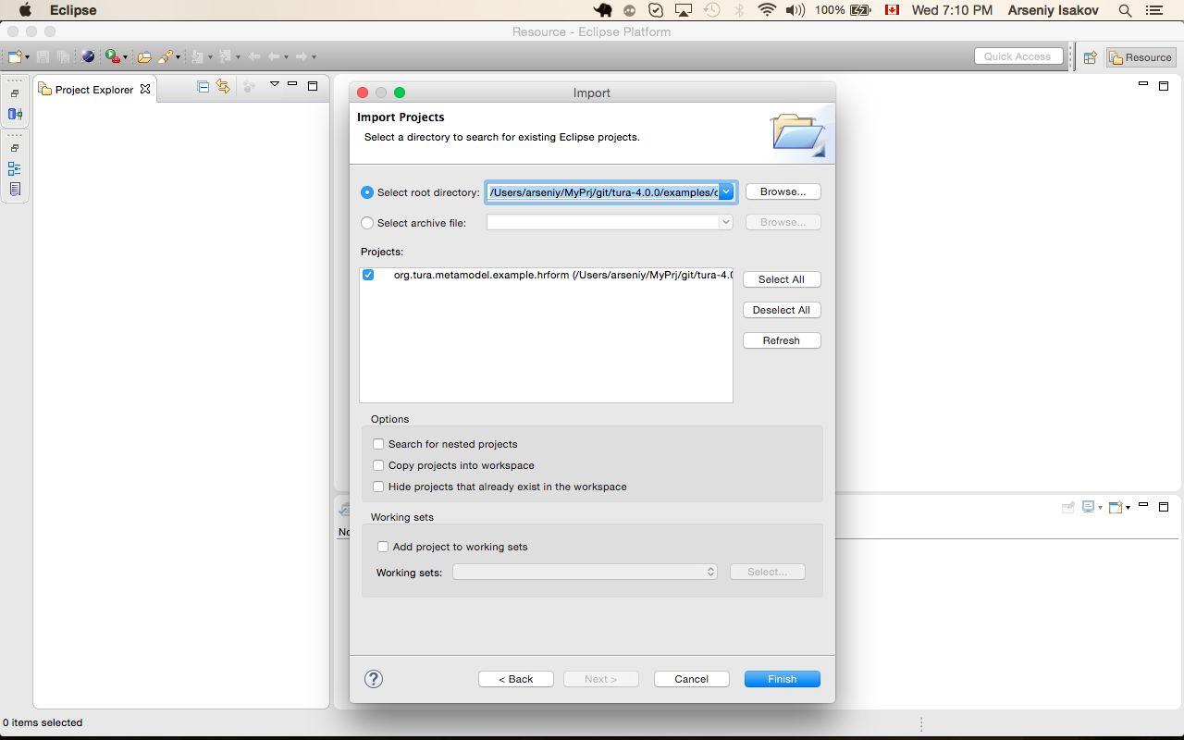

1. Open metamodel

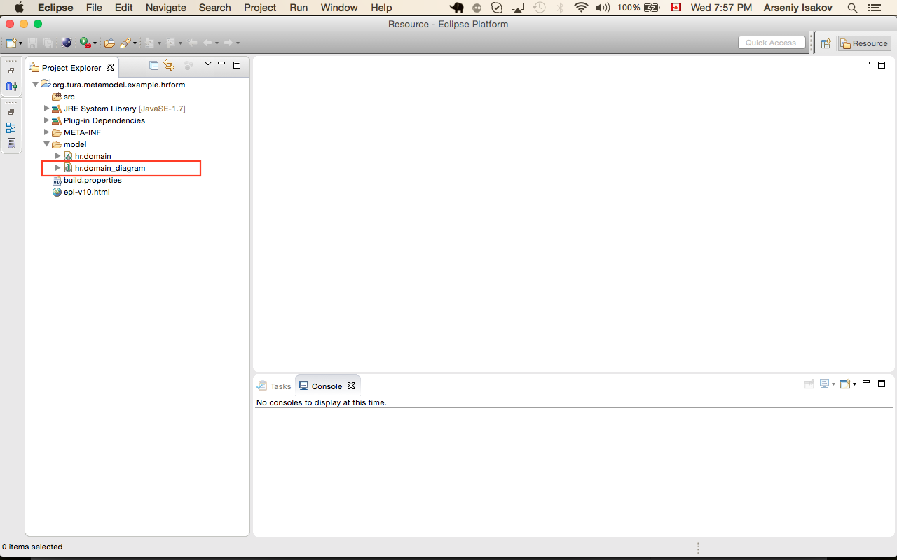

1. Navigate to Service generation recipe

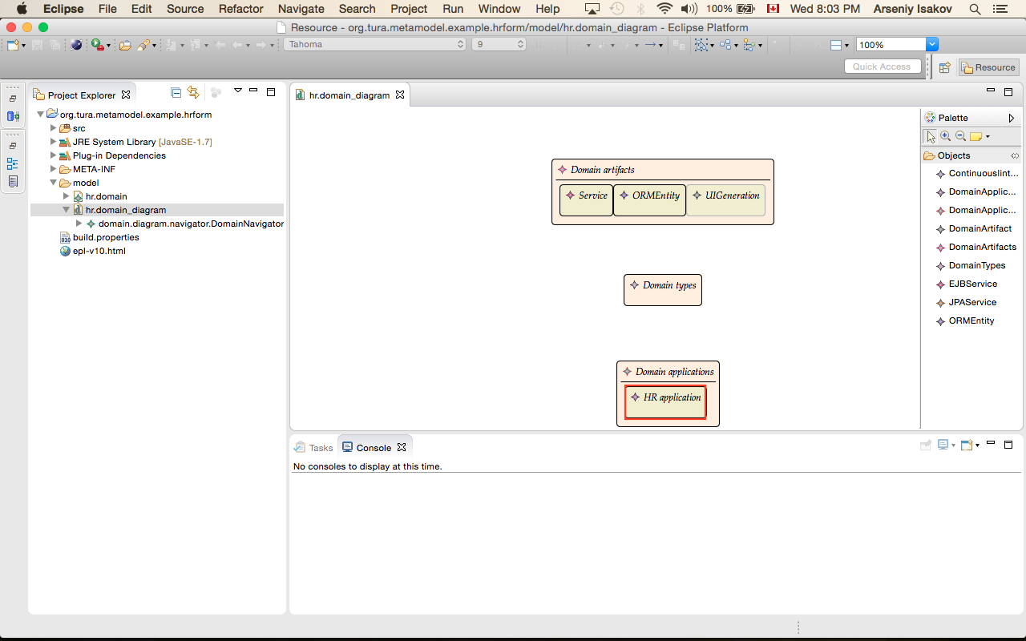

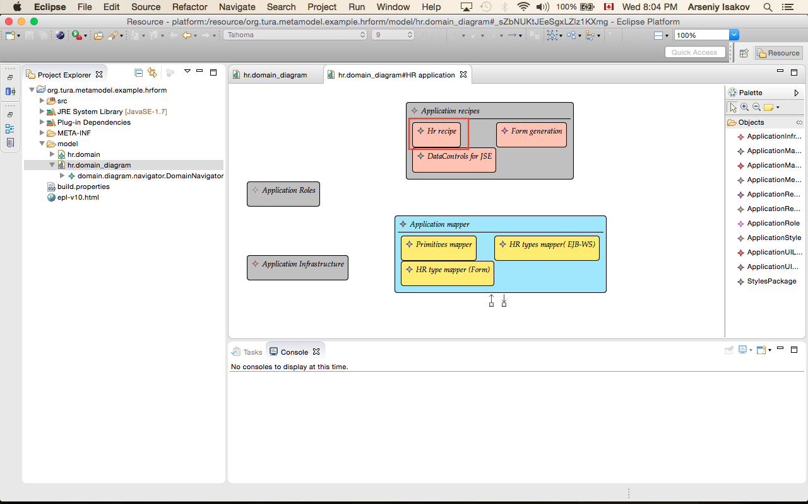

1. Modify generation properties based on your infrastructure setup

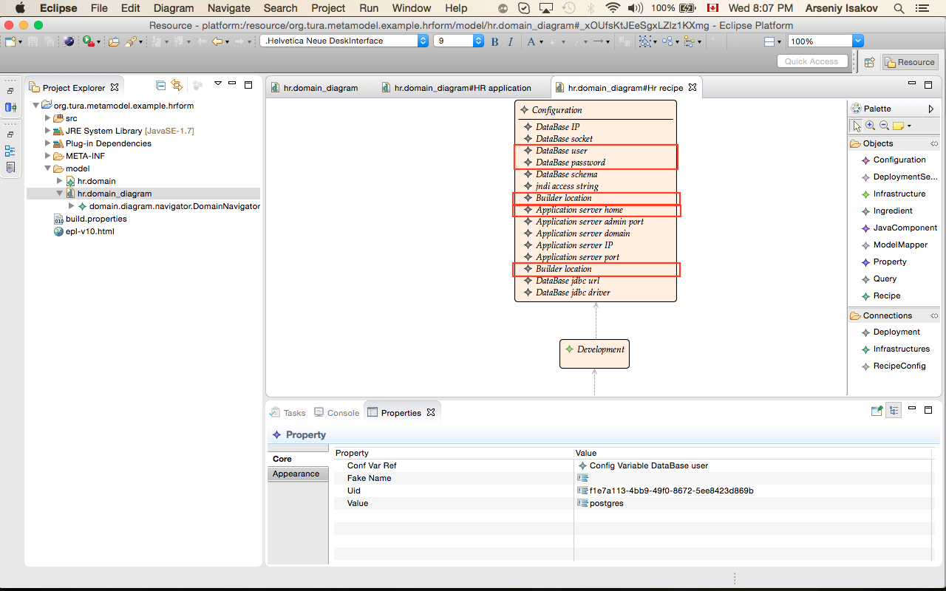

1. For this recipe you have 3 java component:

* HR Objects
* HR Services
* HR services proxy client

For all java component you have to fix location of generated artifacts:

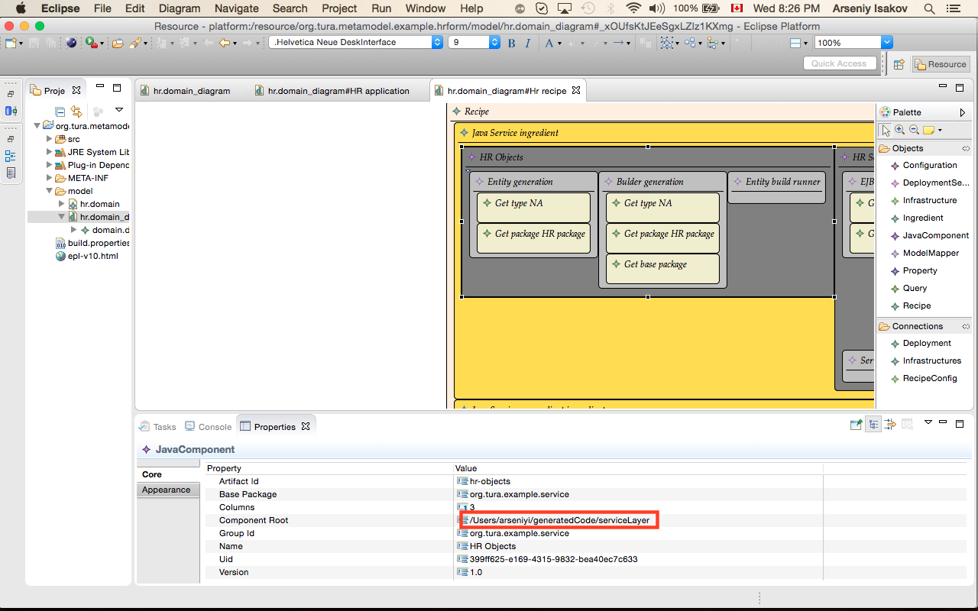

1. Generate sources

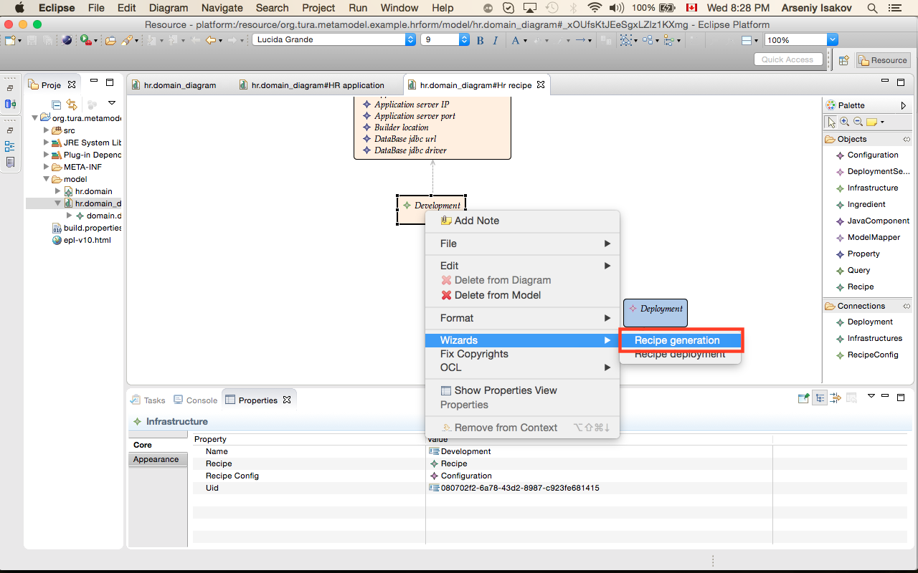

1. Deployment sources

|  |
| --- |
| If you have version jdk higher then 1.7.0_51 you will get an error during deployment process. This issue related to bug <https://java.net/jira/browse/GLASSFISH-21047>.  Anyway run deployment process to build all components. Some of them we will use later. |

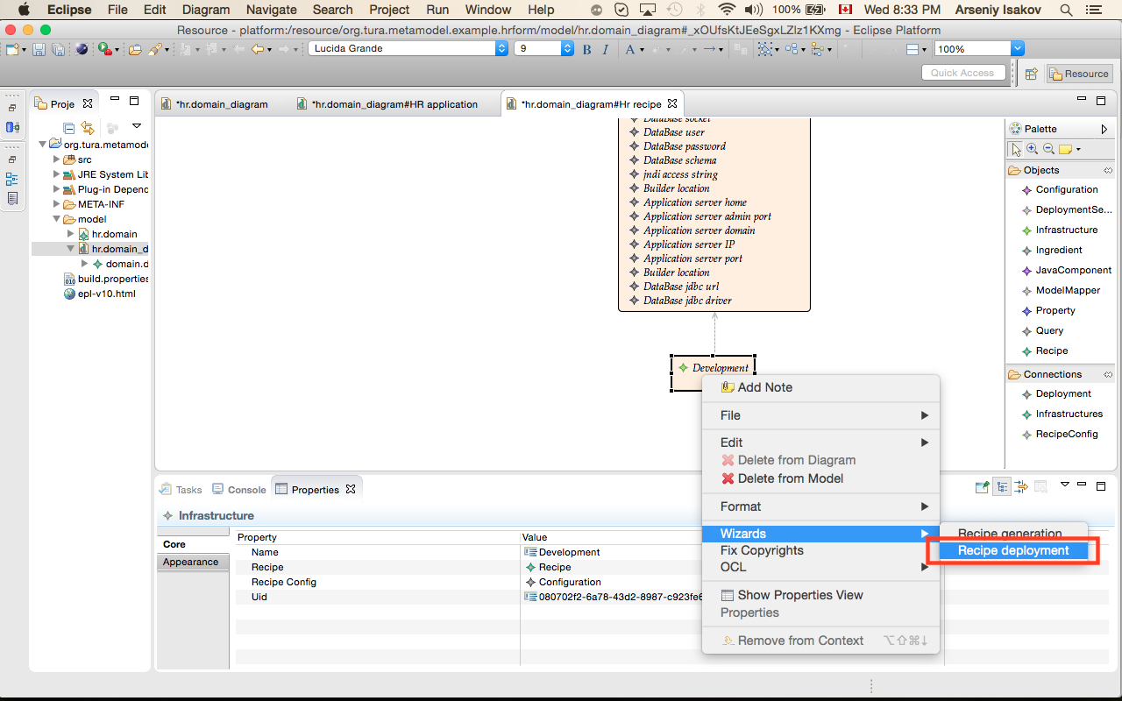

1. Navigate to “Forms generation” recipe



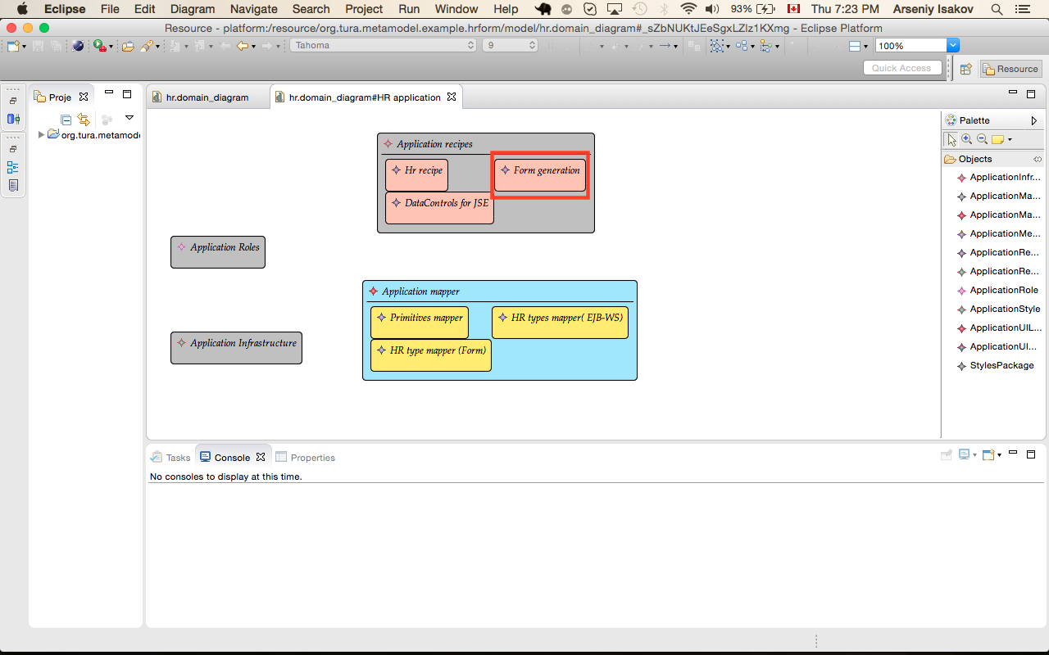

1. Modify generation properties based on your infrastructure setup

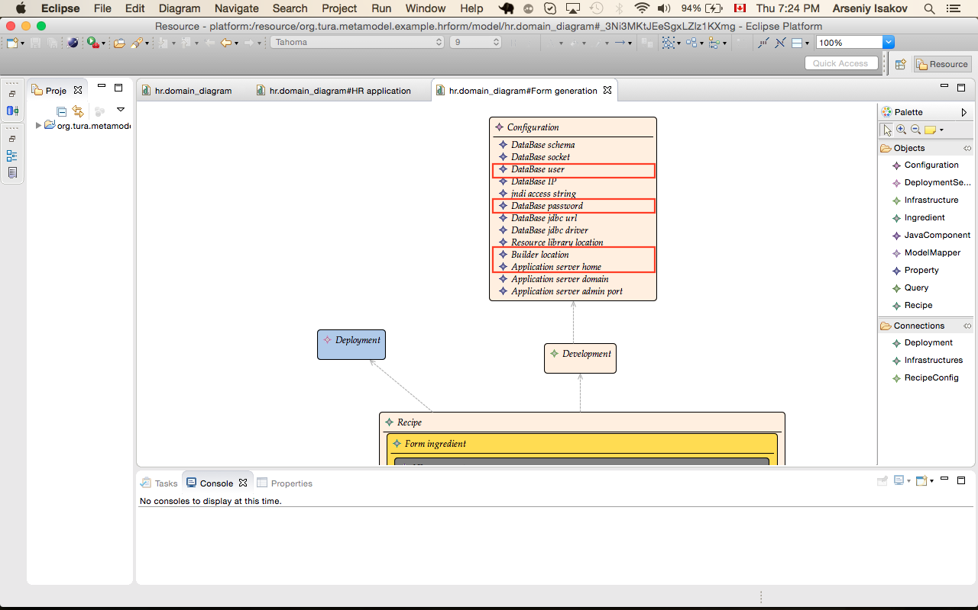

1. For this recipe you have 2 java component:

* UI component
* Forms interface

For all java components you have to fix location of generated artifacts:

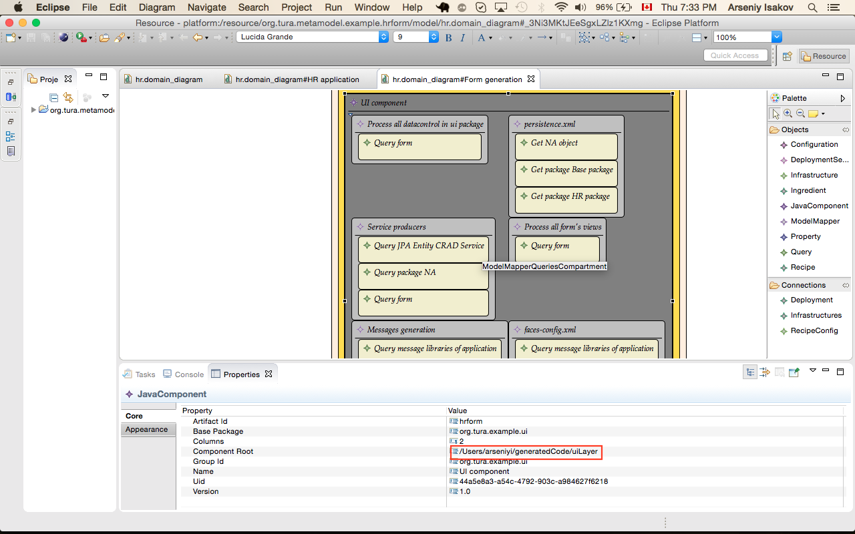

1. Generate application sources

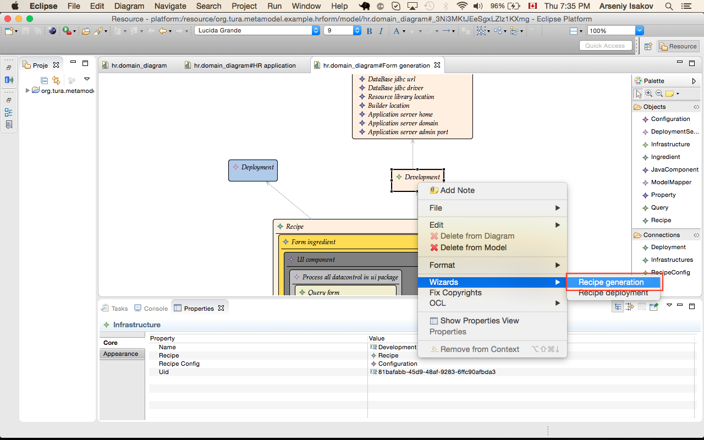

1. Deploying artifacts

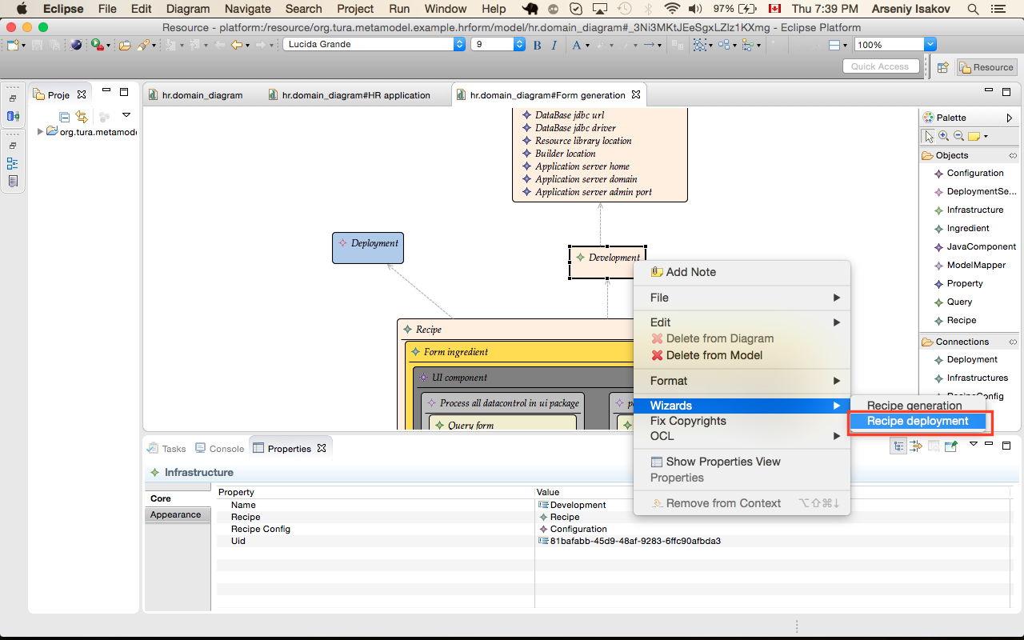

1. First run of deployment will give you an error

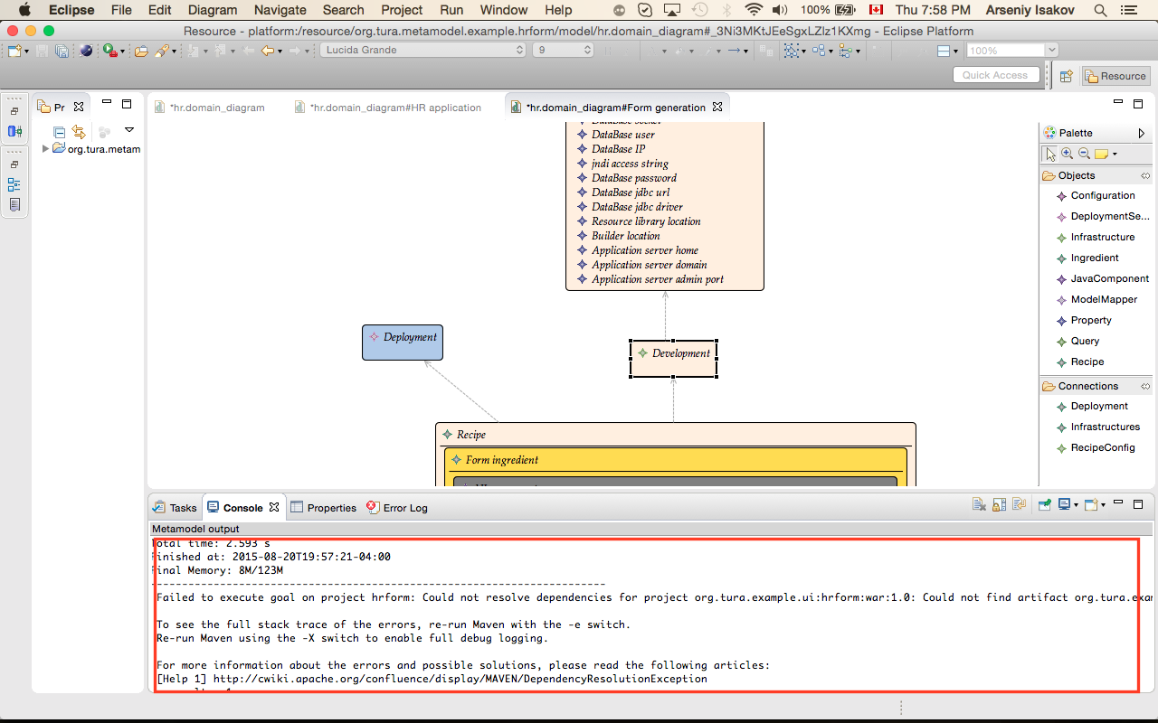

1. Building triggers and resource module

From terminal execute command:

|  |
| --- |
| >cd <tura_extract_dir>/examples/hrform-triggers  >mvn clean install  >cd <tura_extract_dir>/examples/hrresources  >mvn clean install |

1. Deployment resource module

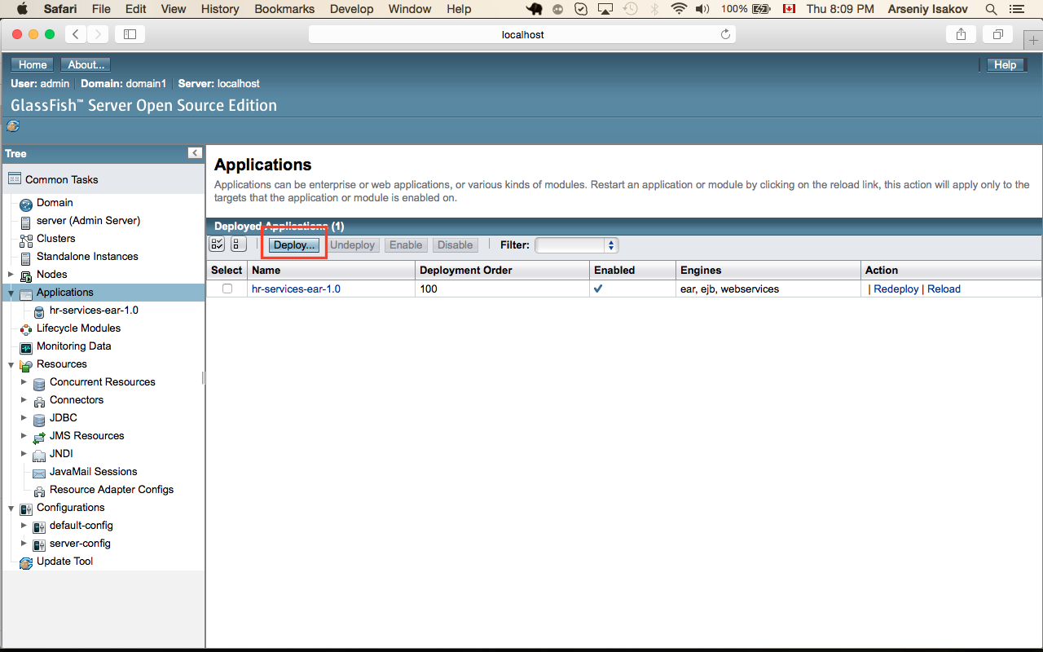

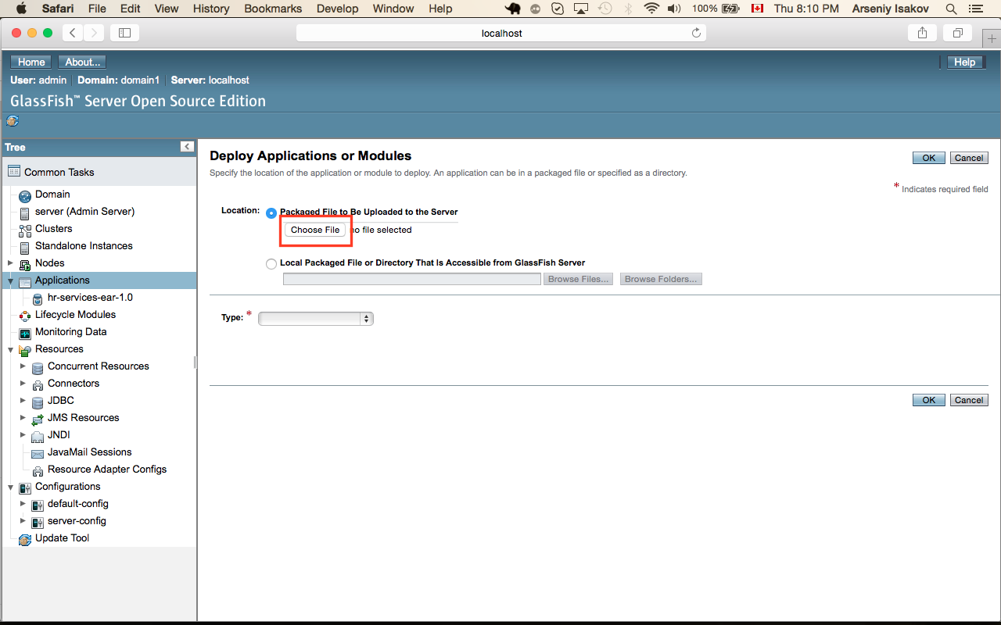

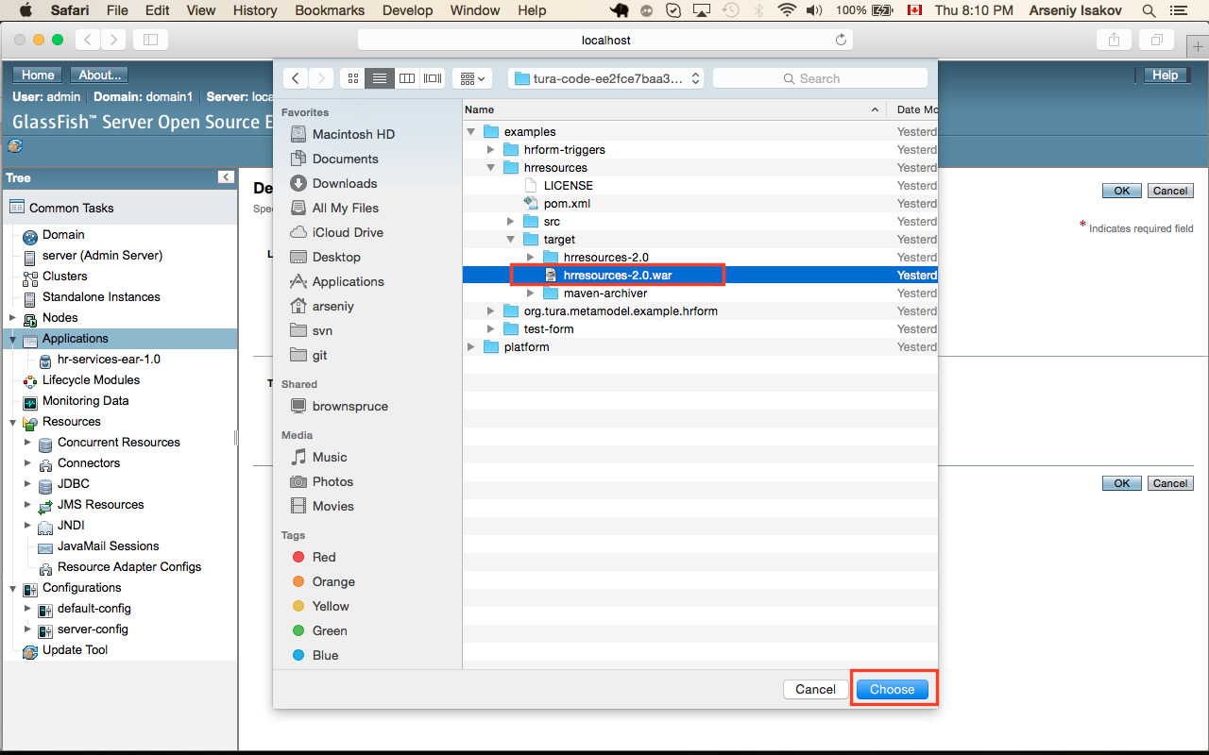

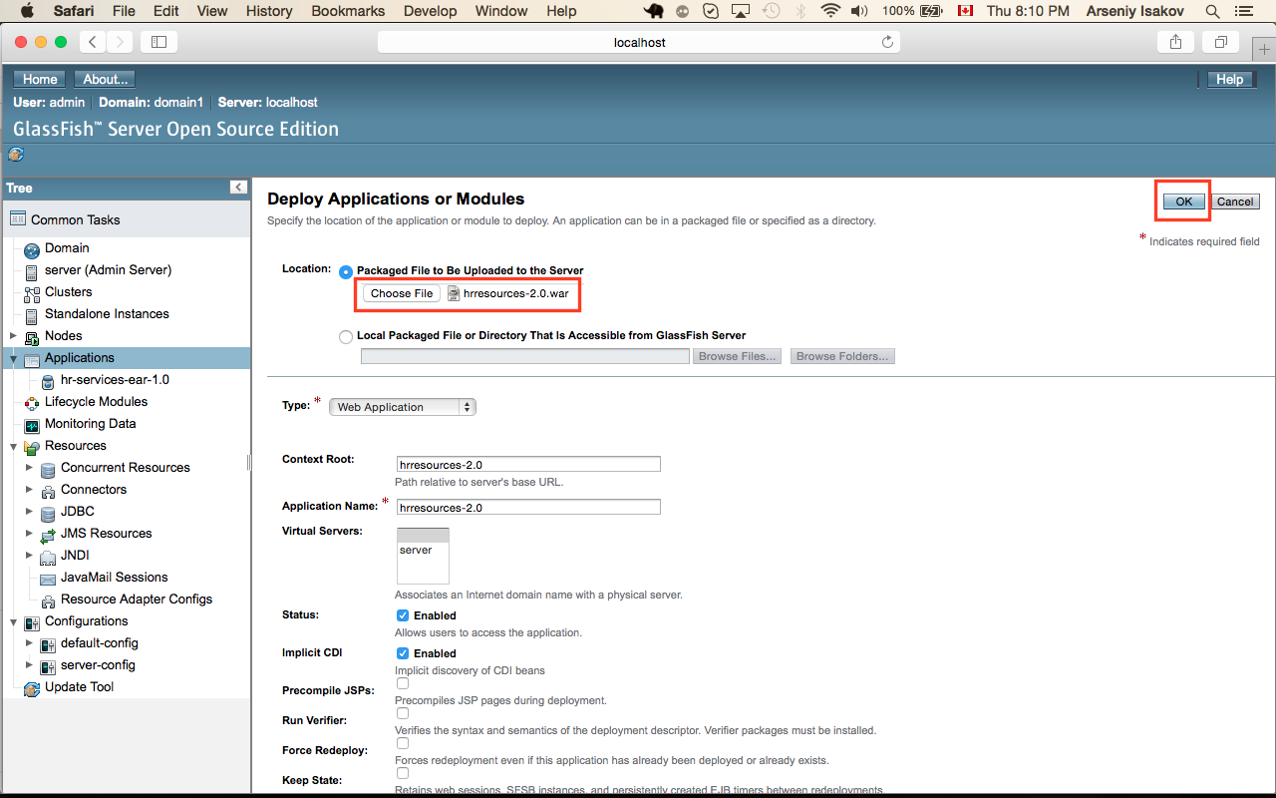

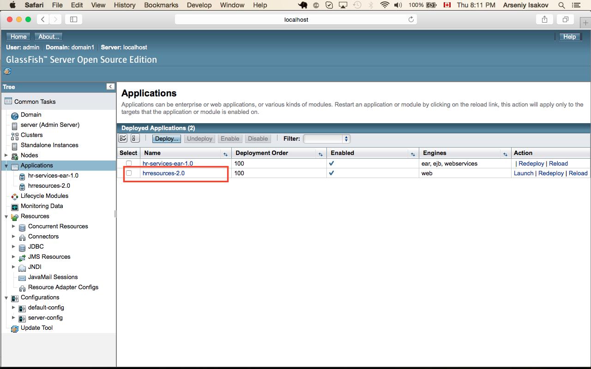

1. Deploying artifacts



You can see result of deployment in glassfish admin console

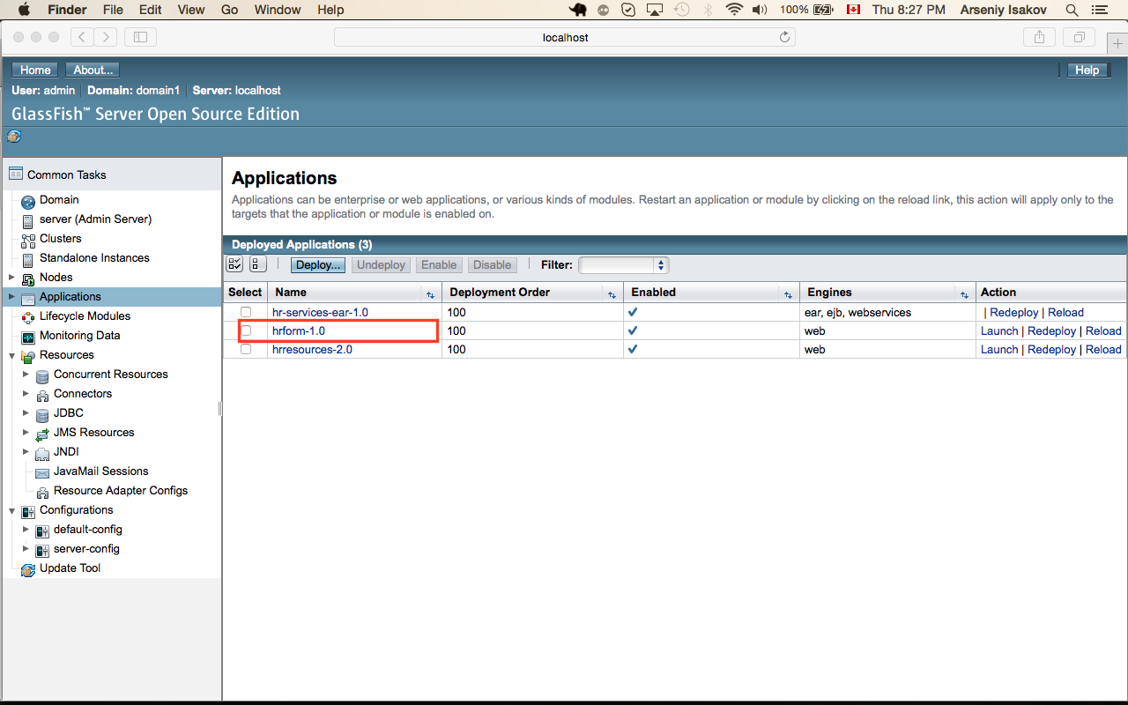

1. Test forms

<http://localhost:8080/hrform-1.0/hrmanager/hrcontroller/HRController.xhtml?param1=qwerty2>